20 Books to Read
Before you Leave Y1
Here’s a list of books to try and read in Year 1. Your challenge is to try and read half of them before the end of the year (if you’ve already read them, you can tick them off, but they don’t count towards this year!)
The first row are books you may read as part of your curriculum, so please only read them when your teacher gives them to you or after the term it is used! The other 3 rows are a mixture of genres, themes and classic or modern stories. Try to mix up your choices and then post a review on your class’s reading blog. Every half term the best reviews will win a prize!

Guided Reading | The True Story of the Three Little Pigs by Jon Scieska | The Day the Crayons Quit  by Drew Daywait | Owl Babies  by Martin Waddell | Handa’s Surprise  by Eileen Browne | Mama Panya’s Pancakes  by Rich + Mary Chamberlin
 | 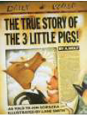 | 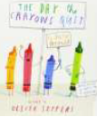 | 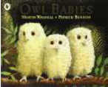 | 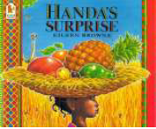 | 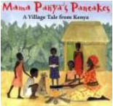
 | I Read/Read to Me: | I Read/Read to Me: | I Read/Read to Me: | I Read/Read to Me: | I Read/Read to Me:
 | Twisted Tales Autumn Term |  |  | Stories from Other Cultures | Stories from Other Cultures
Free Choice | Rosie’s Walk  by Pat Hutchins | Knuffle Bunny  by Mo Willems | Lost and Found  by Oliver Jeffers | Whatever Next  by Jill Murphy | Rainbow Fish  by Marcus Pfister
 | 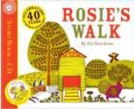 | 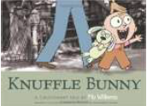 | 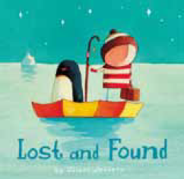 | 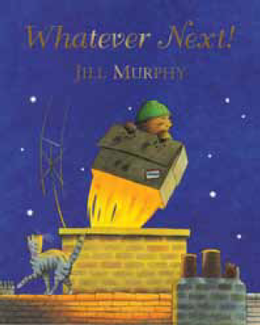 | 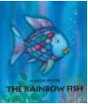
 | I Read/Read to Me: | I Read/Read to Me: | I Read/Read to Me: | I Read/Read to Me: | I Read/Read to Me:
 |  |  |  | EYFS: Expressive Arts and Design | Personal, Social & Emotion Development
 | Peace at Last  by Jill Murphy | Can’t You Sleep Little Bear?  by Martin Waddell | Where the Wild Things Are  by Maurice Sendak | Avocado Baby  by John Burningham | The Tiger Who Came to Tea  by Judith Kerr
 | 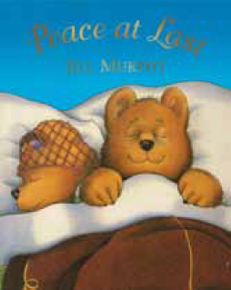 | 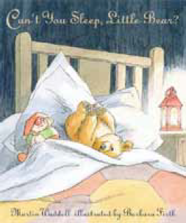 | 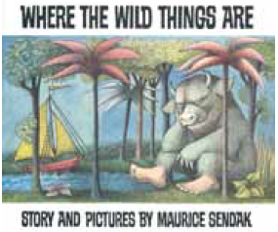 | 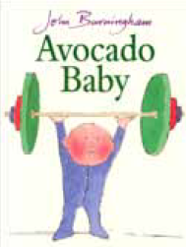 | 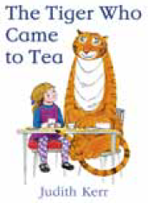
 | I Read/Read to Me: | I Read/Read to Me: | I Read/Read to Me: | I Read/Read to Me: | I Read/Read to Me:
 | Aliens Love Underpants  by Claire Freedman + Ben Cort | The Snail and the Whale  by Julia Donaldson | Cops and Robbers  by Janet + Allan Ahlberg | Dogger  by Shirley Hughes | Beegu  by Alexis Deacon
 | 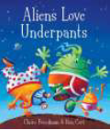 | 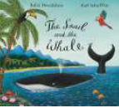 | 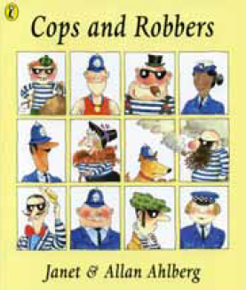 | 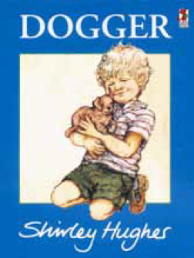 | 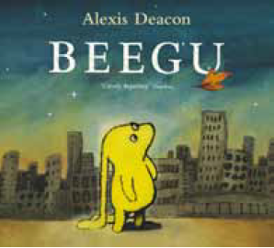
 | I Read/Read to Me: | I Read/Read to Me: | I Read/Read to Me: | I Read/Read to Me: | I Read/Read to Me:

